3 Requirement and Analysis

3.1 Problem Definition

3.1.1 Problem Analysis
The goal is to build a system that converts input text into human-like handwriting by generating a continuous sequence of pen strokes. The key challenges are:
- Sequence generation: handwriting is a long, variable-length time series with dependencies across timesteps.
- Continuous outputs: pen motion is continuous (x/y) plus a discrete pen-up/pen-down state.
- Alignment: text characters must be aligned to stroke segments (often unknown a priori), requiring attention-like mechanisms.
- Style variability: handwriting style differs per writer and even within the same writer; controlling style and “neatness” matters.
- Rendering: generated offsets must be converted into readable SVG/graphics.
In this ref/ implementation, these challenges are addressed with:
- RNN-based model with LSTM layers and an attention window over characters.
- Mixture Density Network (MDN / GMM head) to model continuous coordinates.
- Style priming via pre-saved style samples (styles/style-*-strokes.npy, styles/style-*-chars.npy).
- Bias parameter to control output neatness/diversity.

3.1.2 Existing Problem
Traditional approaches (fonts / rule-based stroke synthesis) often produce:
- Unnatural strokes and spacing,
- Lack of personalization,
- Limited variability and poor realism.

3.1.3 Proposed System
The proposed system is a stroke-based handwriting generator:
- Input: text lines (ASCII) + optional (style, bias)
- Encoding: convert text to integer IDs (drawing.encode_ascii)
- Generation: RNN + attention + MDN predicts stroke offsets and pen state
- Post-process: denoise + align + convert offsets → coordinates
- Render: export SVG via svgwrite

3.2 Requirement Specification

Functional Requirements
- FR1: Accept one or more text lines as input (max length constraint enforced in demo.py).
- FR2: Generate stroke sequences $\left(Δx,Δy,eos\right)$ for each line.
- FR3: Support bias as a controllable parameter affecting neatness/diversity.
- FR4: Support style priming using a small set of reference strokes/characters.
- FR5: Render generated handwriting into SVG output.
- FR6: Allow training from processed dataset arrays (data/processed/*.npy).
- FR7: Save and restore model checkpoints.
- FR8: Record training logs.

Non-Functional Requirements
- NFR1 (Performance): Training/inference should run on CPU; GPU is optional.
- NFR2 (Reproducibility): Config and checkpoints allow runs to be reproduced.
- NFR3 (Usability): Provide simple scripts for training and demo generation.
- NFR4 (Maintainability): Modular separation of data, model, and rendering utilities.

3.3 Planning and Scheduling
An implementation-ready plan aligned to this repository’s workflow:
- Dataset setup
- Collect raw handwriting strokes + transcripts (or use provided processed data)
- Run preprocessing to produce x.npy, x_len.npy, c.npy, c_len.npy
- Model training
- Run train_model.py for a fixed number of steps
- Monitor logs; periodically save checkpoints
- Sampling & demo
- Restore a checkpoint
- Generate samples with/without priming; tune bias
- Render SVG outputs
- Testing & validation
- Visual inspection of SVGs
- Sanity checks on data shapes and lengths

3.4 Software and Hardware Requirements

Software Requirements
- Operating System: Windows / Linux
- Python: 3.x (commonly used with TF 1.x codebases)
- Core Libraries:
  - TensorFlow 1.x compatible runtime
  - NumPy
  - svgwrite
  - Matplotlib (for visualization)

Hardware Requirements
- Minimum: CPU-only machine, 8GB RAM (more recommended for training)
- Recommended: NVIDIA GPU + CUDA-compatible setup for faster training
- Storage: enough for datasets + checkpoints + logs (hundreds of MB to GB depending on dataset)

3.5 Preliminary Product Description
The system provides two main capabilities:
- Training: learns a handwriting synthesis model from stroke/text sequences and saves checkpoints.
- Generation: synthesizes handwriting from new text, with:
  - Priming (style imitation via reference samples)
  - Bias control (neatness vs diversity)
  - SVG export for downstream use
The output is a set of SVG files containing realistic stroke paths suitable for preview, printing, or embedding in documents.

3.6 Conceptual Diagrams
The following diagrams describe the same system visually.

3.6.1 Event Table
Event ID | Trigger / Event | Input | Processing (High-level) | Output
E1 | Generate synthetic data | --num_samples | synthesize_training_data.py creates stroke/text arrays | data/processed/*.npy
E2 | Prepare/validate dataset | raw strokes + ascii | prepare_data.py normalizes/splits/serializes | processed .npy
E3 | Train model | processed .npy | train_model.py → rnn.fit() training loop | checkpoints + logs
E4 | Generate handwriting | text lines (+ style/bias) | demo.py samples nn.sampled_sequence | stroke sequences
E5 | Render/export | strokes | drawing.py + svgwrite renders strokes | .svg images

3.6.2 Use Case Diagram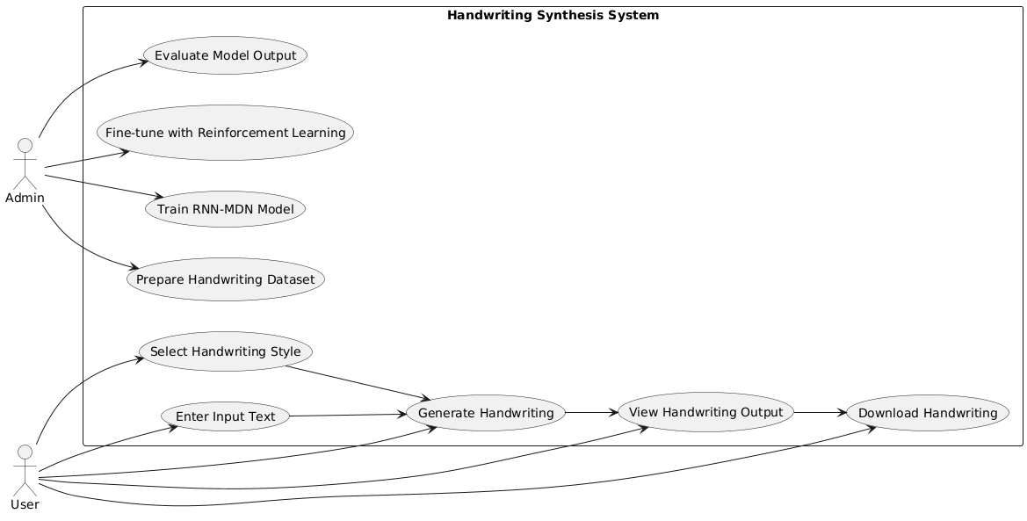

3.6.3 ER Diagram
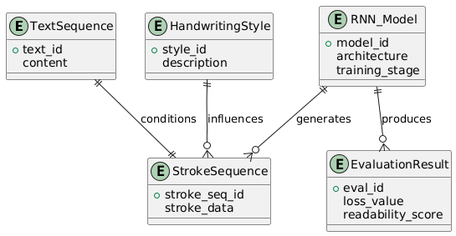

3.6.4 Class Diagram
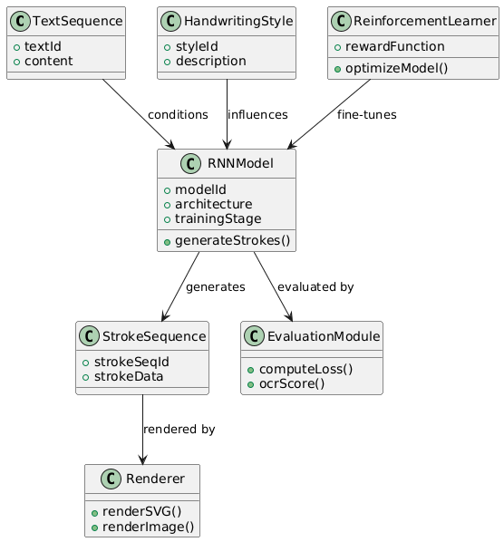

3.6.5 Object Diagram
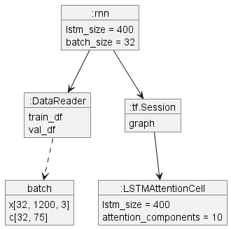

3.6.6 Activity Diagram

3.6.7 Sequence Diagram
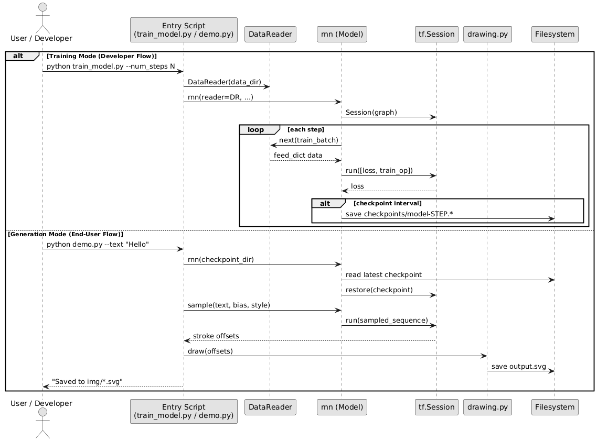

3.6.8 State-Flow Diagram

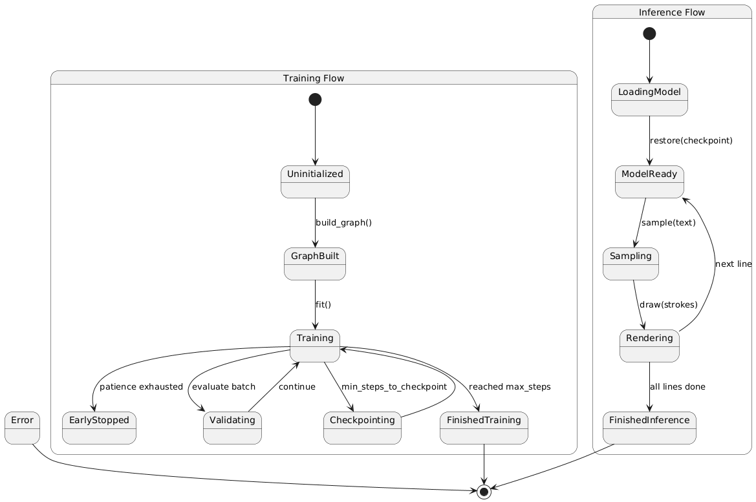

3.6.9 Context Diagram
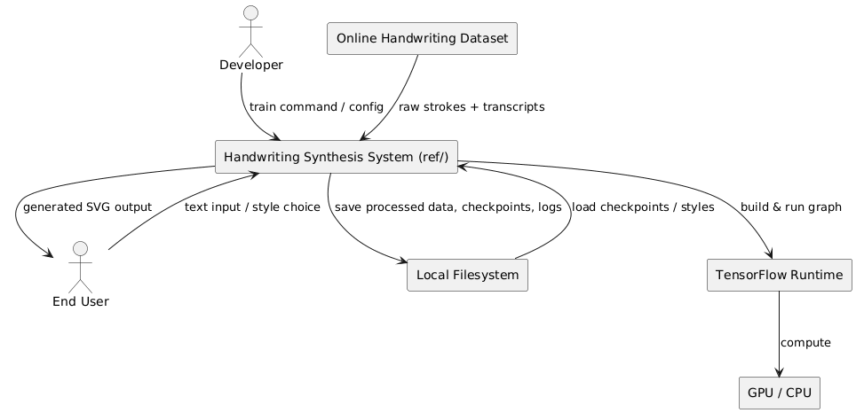

3.6.10 Data Flow Diagram

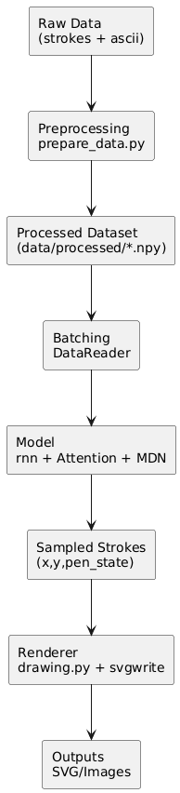

3.6.10 Component Diagram
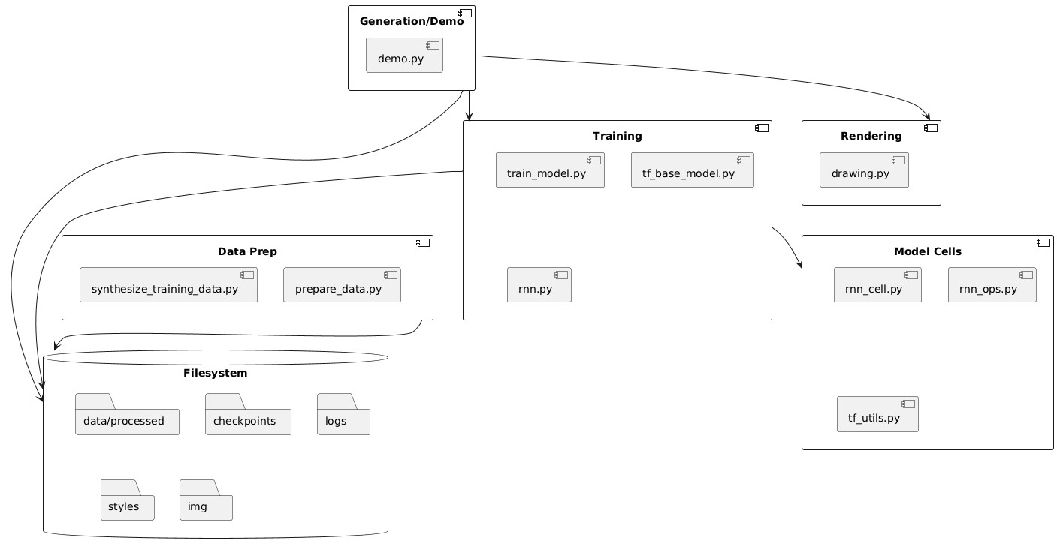

3.6.12 Package Diagram

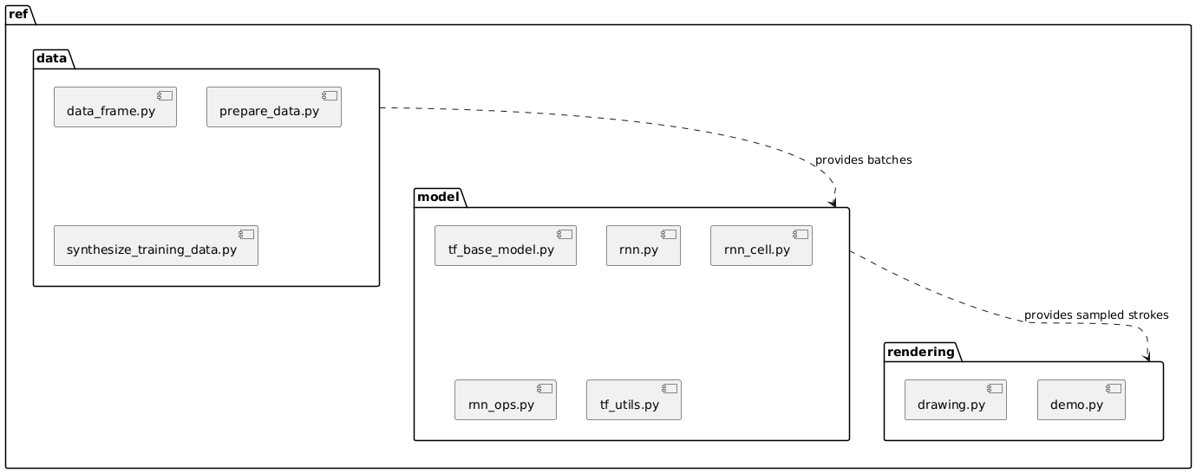

3.6.9 Depolyment Diagram
